**User manual for the Cannabis-Wisconsin Card Sorting Task (C-WCST)**

**developed by Giovanni A. Giaquinto**

**giaquinto1991@gmail.com**

**Theoretical Background**

The original Wisconsin Card Sorting Test (WCST), developed in 1948, was created in order to assess complex cognitive strategies in ‘normals’ (Grant & Berg, 1985). Since its creation many variations have been developed, which assess a wide range of psychological topics. The most common version of the WCST focuses on learning strategies for color, form, and number sorting (Grant & Berg, 1985).

The common used version consists of 128 cards that have either one to four symbols (stars, triangles, circles, or cross signs) in one of four colors (red, green, blue, or yellow). Participants are presented with one of the cards and are asked to figure out the active sorting rule, by placing the presented card on one of four card piles. Cards can be sorted based on the number of symbols on the card, the color of the symbols on the card, or the shape of the symbols on the card. After choosing a card pile, the participant will receive feedback on how they have done. By trial-by-error participants should be able to figure out the active rule. After a while the active sorting rule changes, without notifying the participant. Again using feedback participants should be able to figure out the new active sorting rule. If participants are cognitively flexible few errors shall be made. A few errors are inevitable though, due to the change of sorting rules. An example of the procedure can be seen in Figure 1. Figure 1. *Example of a Trial in WCST*

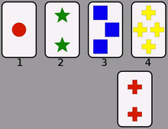In this example, if the active rule would be color, the correct answer would be card pile number one. If the active rule would be shape, the correct answer would be pile numer 4. Lastly, if the active rule would be number the correct answer would be card pile number 2.

The C-WCST globally follows the procedure of the common used WCST. It differs on the amount of cards that are presented and the symbols that are showed on the cards. This is done, because the C-WCST aims to measure an attentional bias, an unusual shift in attention to a certain object/scene/context/etc., in frequent cannabis users. The symbols on the cards of the C-WCST are replaced by a football, a shoe, a screw, and (most importantly) a joint. The idea is that frequent cannabis users have an attentional bias towards cannabis related stimuli. This attentional bias should results in slower reaction times when participants are presented with the joint-cards. Specifically, the C-WCST consists of 72 trials where the sorting rule changes every four cards.

**Requirements**

1. The software is coded in Presentation. To download Presentation follow [this link](https://www.neurobs.com/menu_presentation/menu_download/current) .
2. Presentation can only be run on Windows computers. System recommendations can be found [here](https://www.neurobs.com/menu_presentation/menu_hardware/system_configuration).
3. Stimuli are provided, if one however wishes to use their own created stimuli it is important to note only one of the four symbols depicted on the cards should be a cannabis related stimulus. Otherwise the attentional bias cannot be assessed.
4. Stimuli filenames should consist of 3 character. The first character should indicate the shape of the symbol, the second character the number of symbols, and the third character the (background) color of the symbols.

**Design**

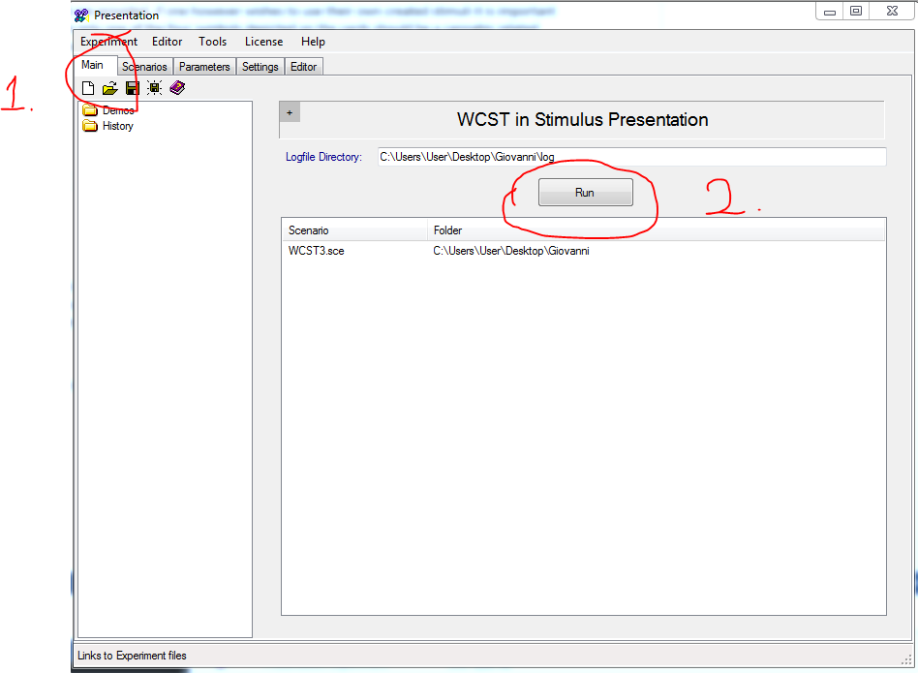 To run the experiment users will have to go to the main tab of the presentation screen (1) and click the run (2) button to start the experiment. The user will be presented with asked to fill in a participant id. I recommend to use a number ID, because this will lead to a clearer overview in your logifle. After this a screen showing ready will be seen. The user (or participant) has to press the return button to start the experiment.

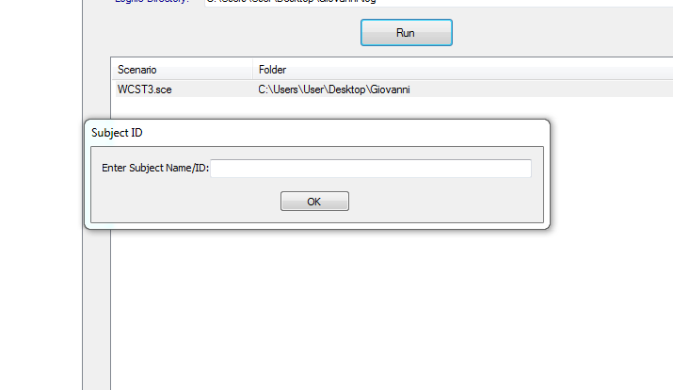

Participants will be instructed via an instruction screen programmed in the experiment. After the instructions, the experiment starts. After each response, participants receive feedback on their answer (right or wrong) and Presentation will add a line to the custom output file, which will be stored in a .txt-file. The trialnumber, presented stimulus name, response, reaction time, number of correct answers and the percentage of mistakes will be printed. This is repeated 72 times. After the 72nd trial, the participant will be prompted with a thank you-screen.

**Flowchart**

**External – User Internal - Software**

Press Return-buttonn

Store data in custom output file

Incorrect feedback

Repeat 72 times

Correct feedback

Assess answer

Select card pile

Present main trial

Read instructions

Initialize loop

Store in custom output file

Initialize experiment

Answer demographic questions

**Screenshots**

Software-code

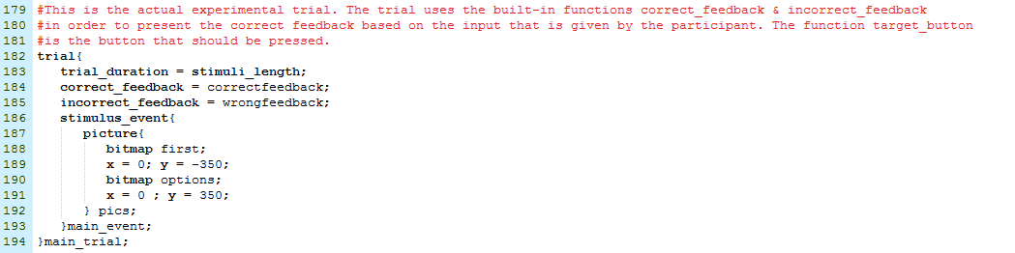

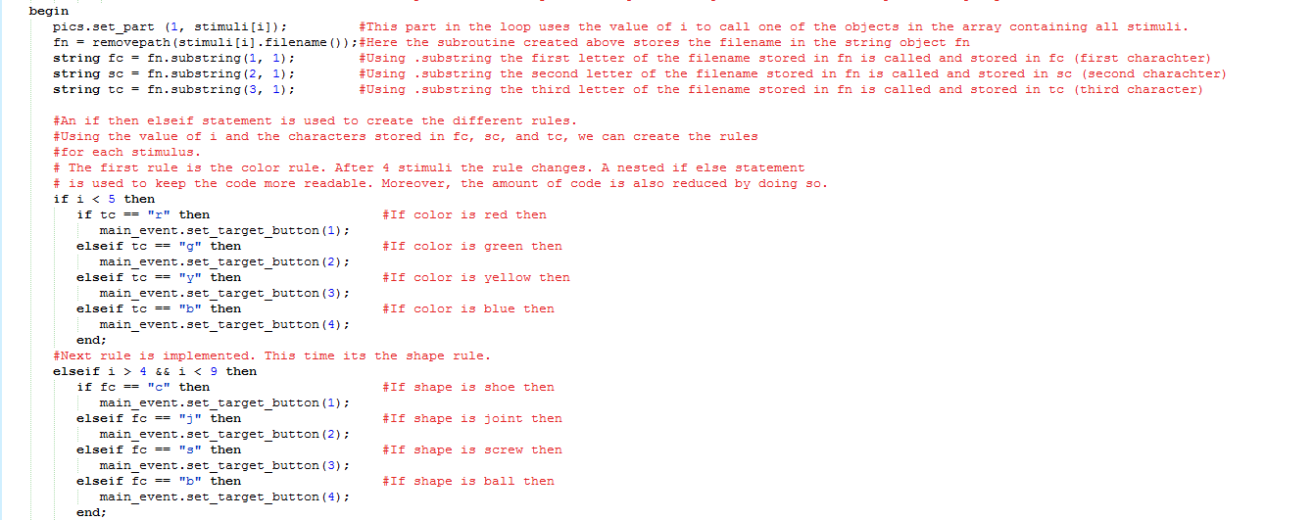

Example of trial

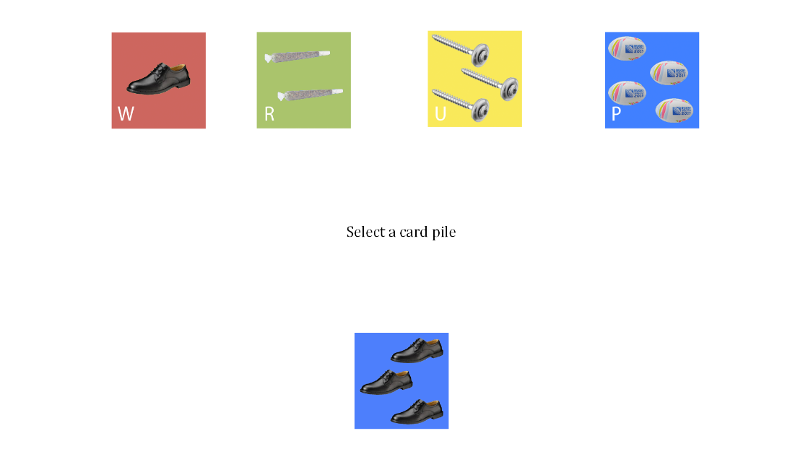

**Step-by-step user guide:**

1. To download the experiment file and scenario file [click this link](https://github.com/GiovanniGiaquinto/WCSTinStimulusPresentation).
2. On this page press the download button.
3. Unzip the downloaded folder and store the documents on a place on your computer where you can find it.
4. To load the experiment and scenario, double click the WCST.exp file and the WCST3.sce file.
5. To run the experiment press run on the main tab of the presentation screen.
6. Enter a participant ID.
7. Press the return/enter-button to start the experiment.